Assignment5

Bootstrap 2

Output Screenshot

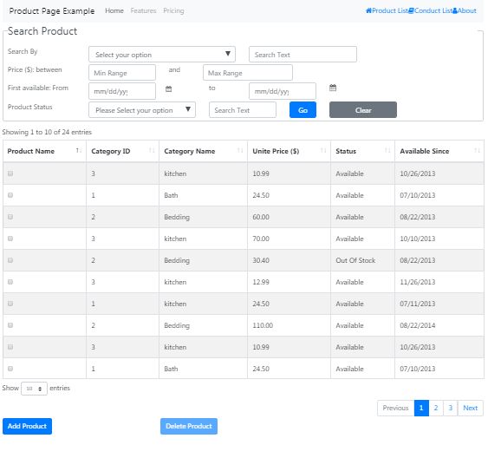

Code Snippet

<!DOCTYPE html>

<html xmlns="http://www.w3.org/1999/xhtml">

<head>

<title></title>

<meta name="viewport" content="width=device-width, initial-scale=1">

<!-- datatable-->

<link href="https://cdnjs.cloudflare.com/ajax/libs/twitter-bootstrap/4.1.1/css/bootstrap.css" rel="stylesheet" />

<link href="https://cdn.datatables.net/1.10.19/css/dataTables.bootstrap4.min.css" rel="stylesheet" />

<link rel="stylesheet" href="https://cdnjs.cloudflare.com/ajax/libs/font-awesome/4.7.0/css/font-awesome.css">

<script src="https://code.jquery.com/jquery-3.2.1.slim.min.js" integrity="sha384-KJ3o2DKtIkvYIK3UENzmM7KCkRr/rE9/Qpg6aAZGJwFDMVNA/GpGFF93hXpG5KkN" crossorigin="anonymous"></script>

<script src="https://cdnjs.cloudflare.com/ajax/libs/popper.js/1.12.9/umd/popper.min.js" integrity="sha384-ApNbgh9B+Y1QKtv3Rn7W3mgPxhU9K/ScQsAP7hUibX39j7fakFPskvXusvfa0b4Q" crossorigin="anonymous"></script>

<script src="https://maxcdn.bootstrapcdn.com/bootstrap/4.0.0/js/bootstrap.min.js" integrity="sha384-JZR6Spejh4U02d8jOt6vLEHfe/JQGiRRSQQxSfFWpi1MquVdAyjUar5+76PVCmYl" crossorigin="anonymous"></script>

<script src="https://code.jquery.com/jquery-3.3.1.js"></script>

<!-- datatable-->

<script src="https://cdn.datatables.net/1.10.19/js/jquery.dataTables.min.js"></script>

<script src="https://cdn.datatables.net/1.10.19/js/dataTables.bootstrap4.min.js"></script>

<!-- datatable-->

<style>

.row

{

margin-top:4px;

}

body {

margin: 2rem;

}

.form-rounded {

border-radius: 1rem;

}

select {

border-radius: 1rem;

}

input {

border-radius: 1rem;

}

.navbar-nav {

flex-direction: row;

}

.nav-link {

padding-right: .5rem !important;

padding-left: .5rem !important;

}

/\* Fixes dropdown menus placed on the right side \*/

.ml-auto .dropdown-menu {

left: auto !important;

right: 0px;

}

</style>

<script>

var dataSet = [

["Baking Pan", "3", "kitchen", "10.99", "Available", "10/26/2013"],

["Bath Rug", "1", "Bath", "24.50", "Available", "07/10/2013"],

["Branket", "2", "Bedding", "60.00", "Available", "08/22/2013"],

["Knife Set", "3", "kitchen", "70.00", "Available", "10/10/2013"],

["Mattress Protector", "2", "Bedding", "30.40", "Out Of Stock", "08/22/2013"],

["Pan", "3", "kitchen", "12.99", "Available", "11/26/2013"],

["Clean Towel", "1", "kitchen", "24.50", "Available", "07/11/2013"],

["Window", "2", "Bedding", "110.00", "Available", "08/22/2014"],

["Baking Pan", "3", "kitchen", "10.99", "Available", "10/26/2013"],

["Bath Rug", "1", "Bath", "24.50", "Available", "07/10/2013"],

["Branket", "2", "Bedding", "60.00", "Available", "08/22/2013"],

["Knife Set", "3", "kitchen", "70.00", "Available", "10/10/2013"],

["Mattress Protector", "2", "Bedding", "30.40", "Out Of Stock", "08/22/2013"],

["Pan", "3", "kitchen", "12.99", "Available", "11/26/2013"],

["Clean Towel", "1", "kitchen", "24.50", "Available", "07/11/2013"],

["Window", "2", "Bedding", "110.00", "Available", "08/22/2014"],

["Baking Pan", "3", "kitchen", "10.99", "Available", "10/26/2013"],

["Bath Rug", "1", "Bath", "24.50", "Available", "07/10/2013"],

["Branket", "2", "Bedding", "60.00", "Available", "08/22/2013"],

["Knife Set", "3", "kitchen", "70.00", "Available", "10/10/2013"],

["Mattress Protector", "2", "Bedding", "30.40", "Out Of Stock", "08/22/2013"],

["Pan", "3", "kitchen", "12.99", "Available", "11/26/2013"],

["Clean Towel", "1", "kitchen", "24.50", "Available", "07/11/2013"],

["Window", "2", "Bedding", "110.00", "Available", "08/22/2014"]

];

$(document).ready(function () {

$('#ProductTable').DataTable({

data: dataSet,

columns: [{ title: "Product Name" },

{ title: "Category ID" },

{ title: "Category Name" },

{ title: "Unite Price ($)" },

{ title: "Status" },

{ title: "Available Since" }

],

'columnDefs': [{

'targets': 0,

'searchable': false,

'orderable': false,

'className': 'dt-body-center',

'render': function (data, type, full, meta) {

return '<input type="checkbox" name="id[]" value="' + $('<div/>').text(data).html() + '">';

}

}],

"dom": '<"top"i>rt<"bottom"flp><"clear">',

'searching': false

})

});

</script>

</head>

<body>

<div id="app" class="container">

<nav class="navbar navbar-expand-lg navbar-light bg-light">

<a class="navbar-brand" href="#">Product Page Example</a>

<button class="navbar-toggler" type="button" data-toggle="collapse" data-target="#navbarNavDropdown" aria-controls="navbarNavDropdown" aria-expanded="false" aria-label="Toggle navigation">

<span class="navbar-toggler-icon"></span>

</button>

<div id="navbarNavDropdown" class="navbar-collapse collapse">

<ul class="navbar-nav mr-auto">

<li class="nav-item active">

<a class="nav-link" href="#">Home <span class="sr-only">(current)</span></a>

</li>

<li class="nav-item">

<a class="nav-link" href="#">Features</a>

</li>

<li class="nav-item">

<a class="nav-link" href="#">Pricing</a>

</li>

</ul>

<ul class="navbar-nav justify-content-between">

<li class="nav-item active">

<a href="#"><span class="fa fa-home"></span>Product List</a>

</li>

<li class="nav-item">

<a href="#"><span class="fa fa-book"></span>Conduct List</a>

</li>

<li class="nav-item">

<a href="#"><span class="fa fa-user"></span>About</a>

</li>

</ul>

</div>

</nav>

</div>

<div class="container">

<fieldset class="form-control">

<legend>Search Product</legend>

<div class="row">

<div class="col-lg-2">

<span>Search By </span>

</div>

<div class="col-lg-4">

<select name="SearchBy" class="form-control">

<option value="" disabled selected>Select your option</option>

<option value="saab">Saab</option>

<option value="fiat">sdfg</option>

<option value="audi">Audi</option>

</select>

</div>

<div class="col-lg-3">

<input type="text" placeholder="Search Text" class="form-control" />

</div>

</div>

<div class="row">

<div class="col-lg-2">

<span>Price ($): between </span>

</div>

<div class="col-lg-2">

<input type="text" placeholder="Min Range" class="form-control" />

</div>

<div class="col-lg-1">

<span> and </span>

</div>

<div class="col-log-3">

<input type="text" placeholder="Max Range" class="form-control" />

</div>

</div>

<div class="row">

<div class="col-lg-2">

<span>First available: From </span>

</div>

<div class="col-lg-2">

<input type="datetime-local" class="form-control" placeholder="Min date" />

</div>

<div class="col-lg-1 form-control-sm">

<span class="fa fa-calendar"></span>

</div>

<div class="col-lg-1">

<span> to </span>

</div>

<div class="col-lg-2">

<input type="datetime-local" class="form-control" placeholder="Max date" />

</div>

<div class="col-lg-1">

<span class="fa fa-calendar"></span>

</div>

</div>

<div class="row">

<div class="col-lg-2">

<span>Product Status</span>

</div>

<div class="col-lg-3">

<select name="Status" class="form-control">

<option value="" disabled selected>Please Select your option</option>

<option value="Available">Available</option>

<option value="Out of Stock">Out of Stock</option>

<option value="Limited">Limited</option>

</select>

</div>

<div class="col-lg-2">

<input type="text" placeholder="Search Text" class="form-control" />

</div>

<div class="col-lg-1">

<input type="button" value="Go" class="btn btn-primary form-control" />

</div>

<div class="col-lg-2">

<input type="button" value="Clear" class="btn btn-secondary form-control" />

</div>

</div>

</fieldset>

</div>

<div class="container">

<table class="table table-striped table-bordered" id="ProductTable">

</table>

</div>

<div class="container">

<div class="row">

<div class="col-4">

<input type="button" value="Add Product" class="btn btn-primary" />

</div>

<div class="col-xs-4">

<input type="button" value="Delete Product" class="btn btn-primary disabled" />

</div>

</div>

</div>

</body>

</html>